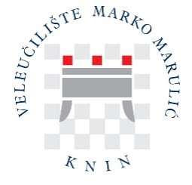
ERASMUS+ Info Sheet
Official name in Croatian | Veleučilište „Marko Marulić“ u Kninu
Official name in English | University of Applied Sciences Marko Marulic of Knin (UAS)
Official abbreviation | UAS
ERASMUS code | HR KNIN01
ECHE | ERASMUS CHARTER FOR HIGHER EDUCATION 2021-2027 published at the  https://www.veleknin.hr/wp-content/uploads/2024/02/Erasmus-charter-for-higher-education-2021-2027.pdf
PIC / OID | 949592268 / E10103339
Address | Petra Krešimira IV 30, HR – 22300 Knin
Dean | Marijana Drinovac Topalović, PhD, College Professor
Vice Dean for Science and International Cooperation | Iva Ljubičić, PhD, College Professor
ERASMUS Coordinator | Sandra Mandinić, Lecturer
Veleknin web site | https://www.veleknin.hr/
Main contact e-mail | erasmus@veleknin.hr

