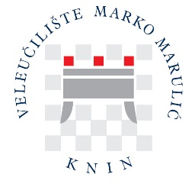

WELCOME

Dear exchange students,

We are very pleased that you are considering your options to realize your mobility within the Erasmus + program at the University of Applied Sciences Marko Marulic of Knin (Veleknin).

Veleknin is a relatively new institution, founded in June 2005, but ambitious, focusing on the professional education of students across five distinct programmes within three departments: Karst Agriculture, Food Technology, and Commercial Business with Entrepreneurship, along with a Specialist Graduate Professional Study in Economics and Normative Framework of Entrepreneurship. All our efforts are directed towards the constant increase of teaching and studying quality. We also offer a high student standard concerning accommodation, subsistence, learning facilities and other student services.

You are welcome to contact us via e-mail (erasmus@veleknin.hr), and we will do our best to provide all the information you need. If you decide to come to Knin, we will make your exchange period a great experience!

Veleknin staff

