**RECOMMENDED ACCOMMODATION**

**Apartments and studio apartments “fra Lujo Marun”**

Student dormitory ”fra Lujo Marun” of the University of Applied Sciences „Marko Marulić“ of Knin is registered as an accommodation facility, hostel and apartment and studio apartment from the group of other hospitality facilities where guests can be accommodated.

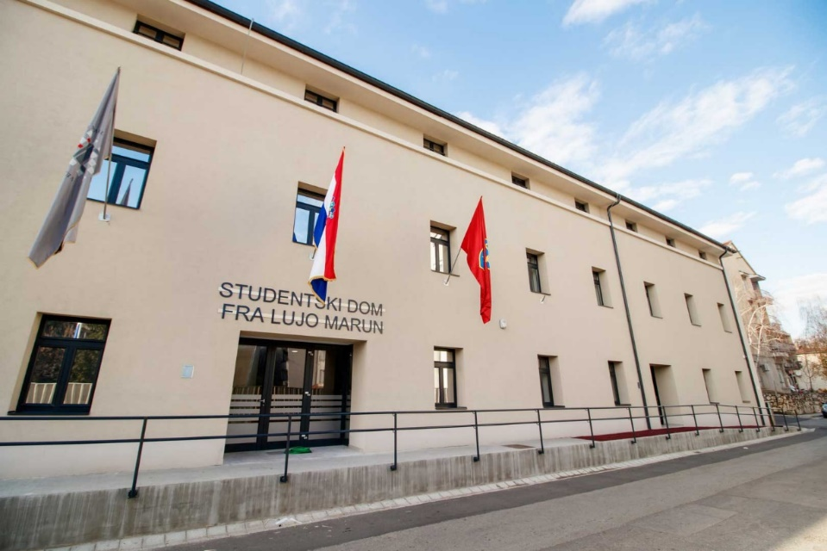

In the Hostel “fra Lujo Marun” there are 28 single and 25 double rooms for a total of 78 guests. Apartments and studio apartments “fra Lujo Marun” are categorized with *** stars and have the following accommodation capacity: 2 studio apartments for 2 people and 3 apartments with one double room (1/2) and 1 extra bed, which makes a total of 10 guests on permanent beds and the possibility of accommodating 3 more guests on additional beds.

The space, with its area, decoration and modern equipment, as well as the quality of the decoration, meets all the requirements for the category of hostels, apartments and studio apartments.

Hostel “Fra Lujo Marun” <https://www.veleknin.hr/en/residence-hall/hostel/>

Send announcements/inquiries for information or accommodation reservations to: [hostel@veleknin.hr](mailto:hostel@veleknin.hr)

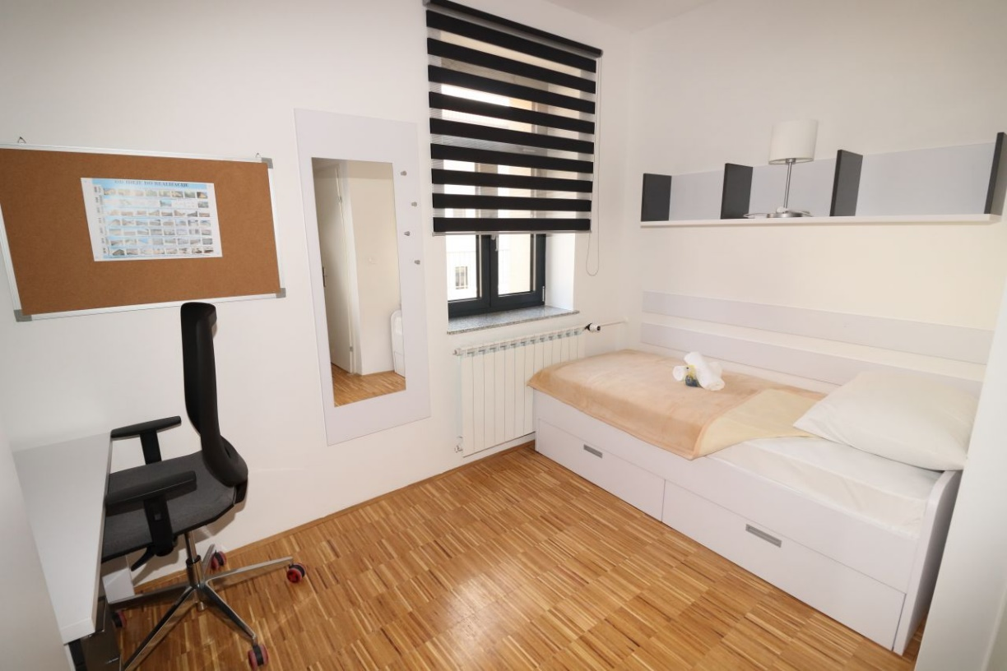

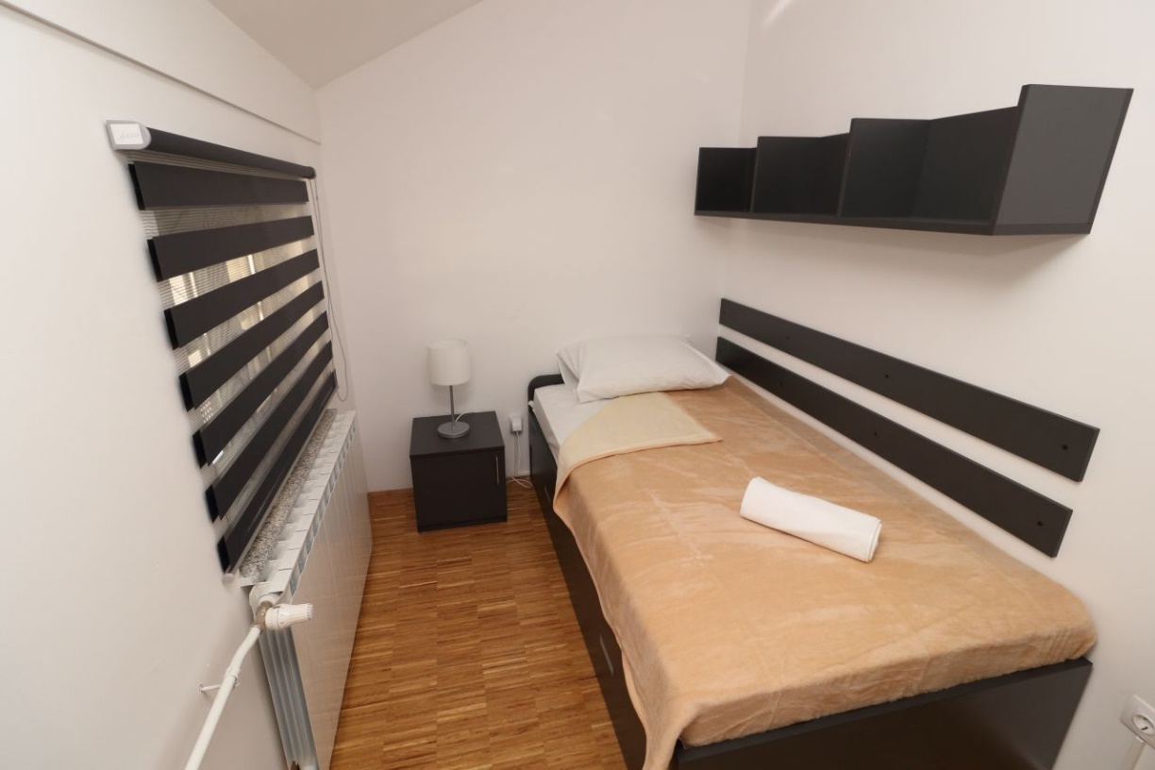

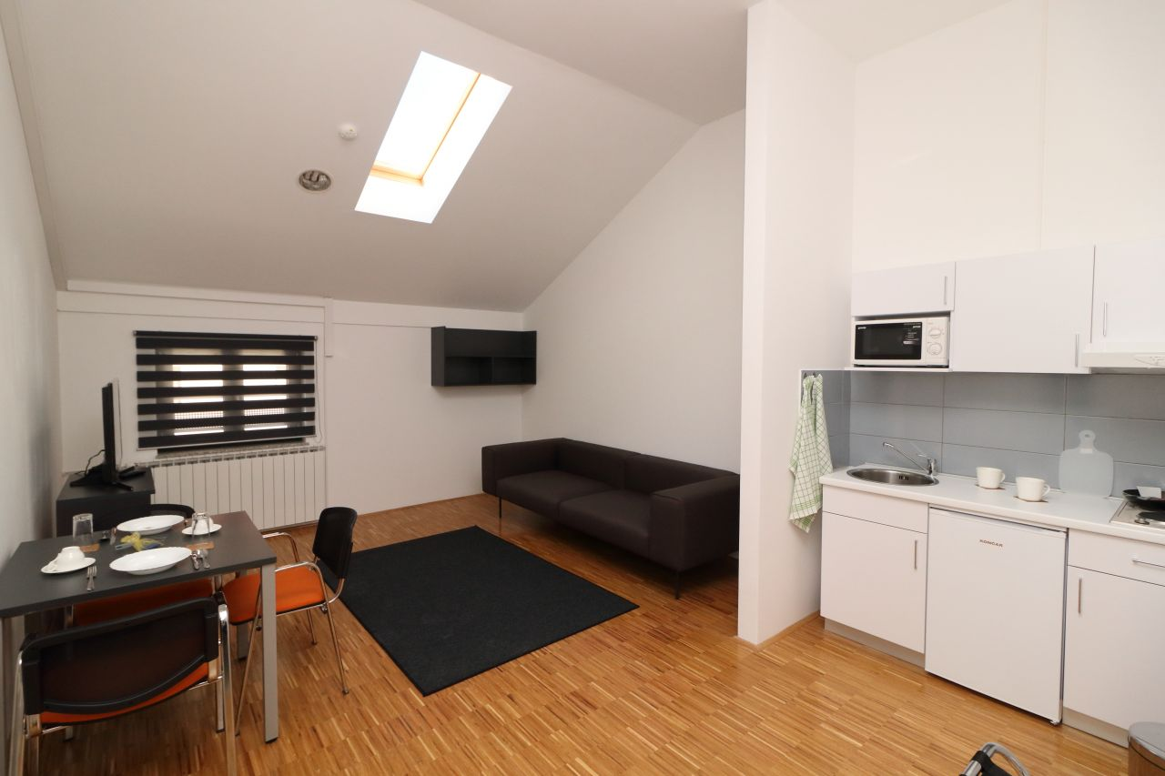

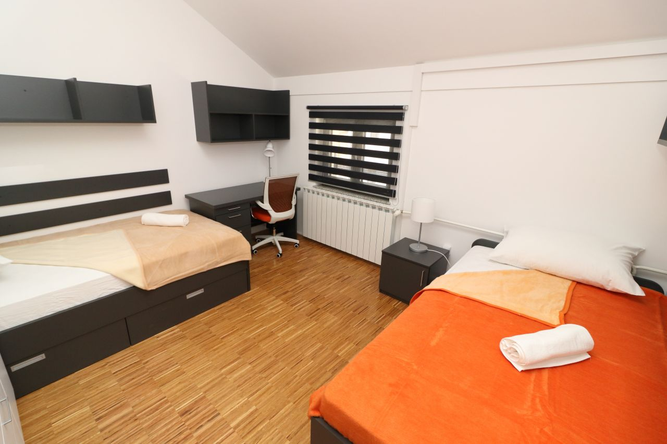

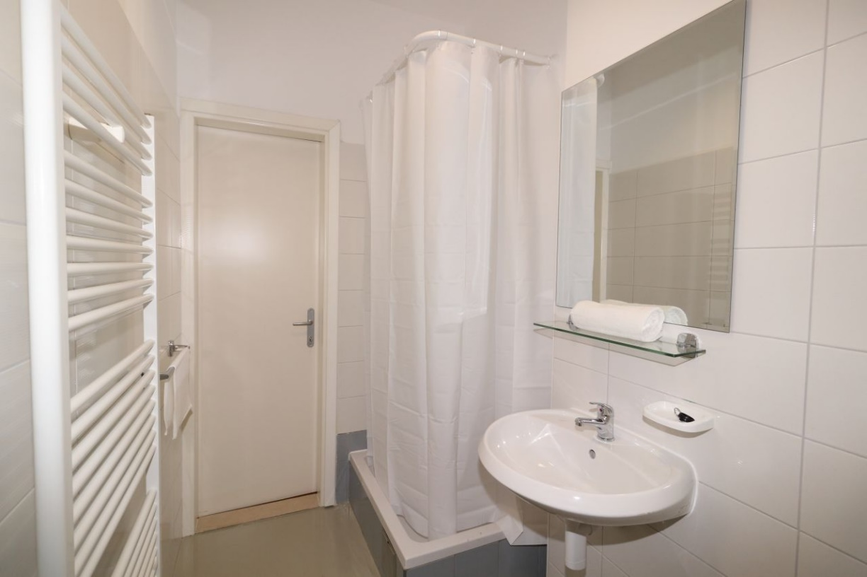

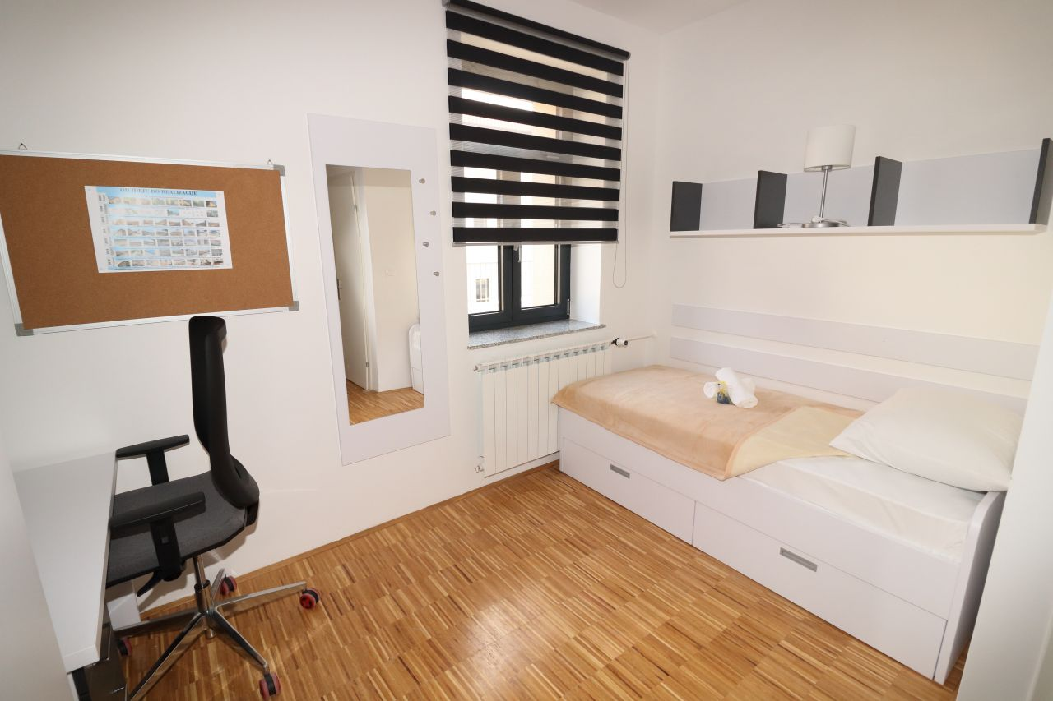

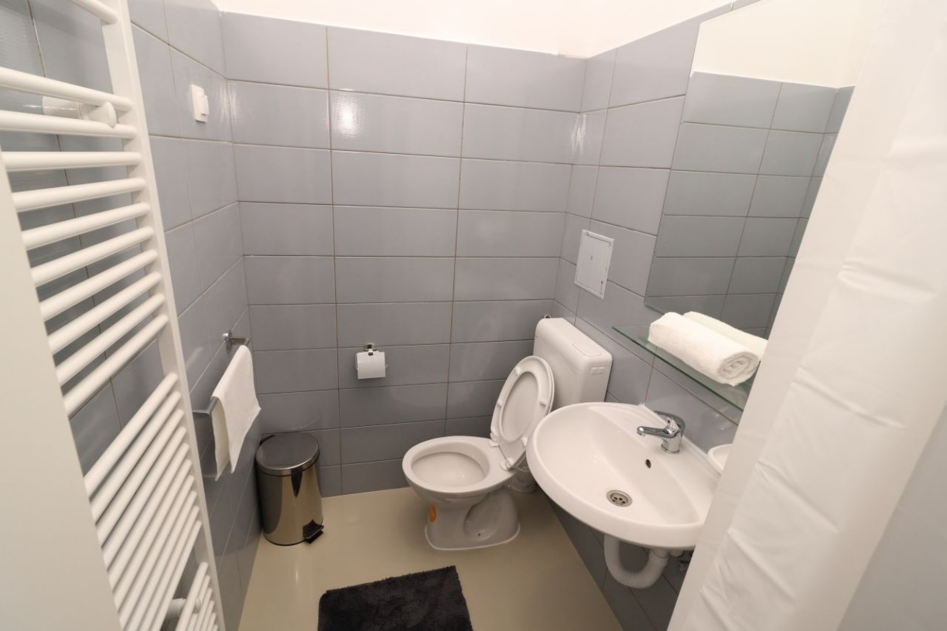

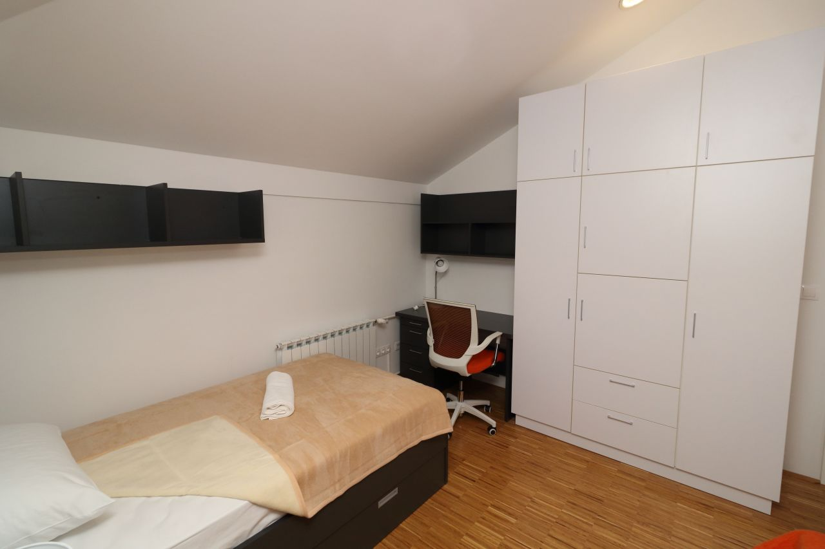

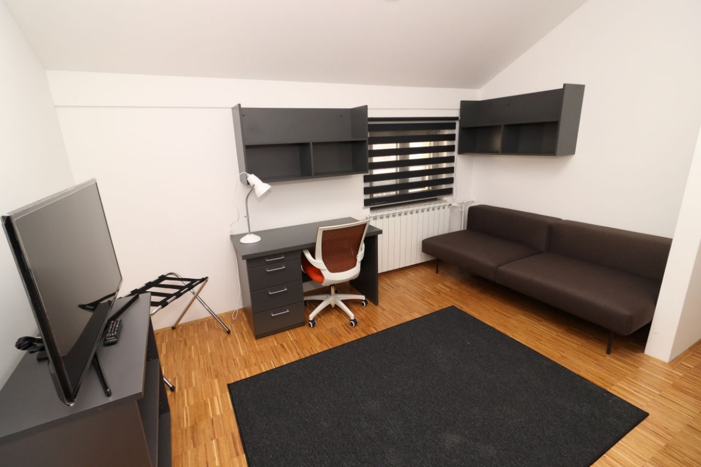

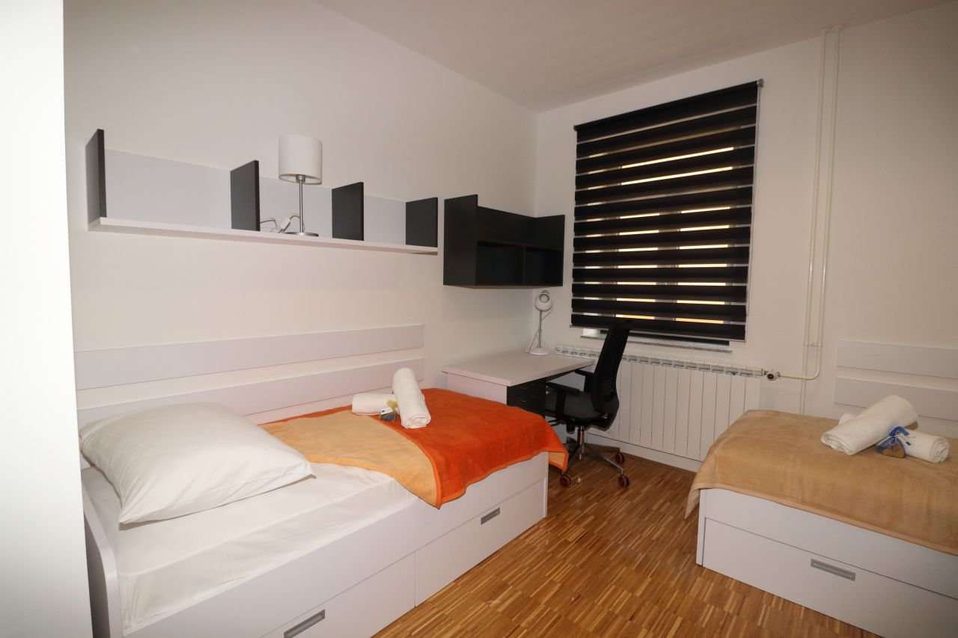

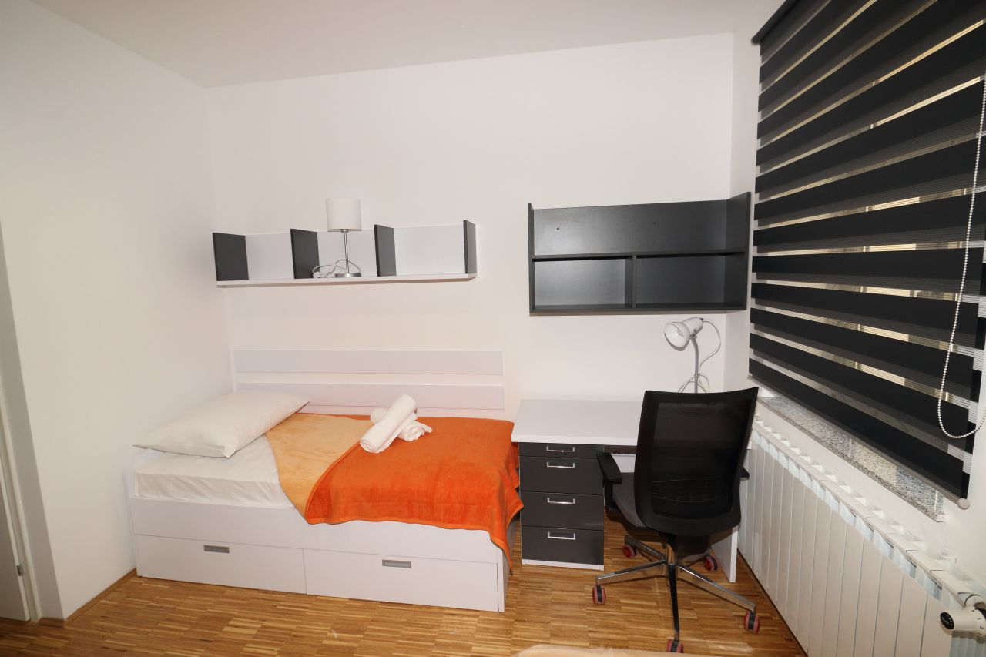

**ADDRESS**

“Fra Lujo Marun” Student Dormitory

King Petar Krešimir IV 22.

22300 Knin, Croatia

**E-MAIL**

[hostel@veleknin.hr](mailto:hostel@veleknin.hr)