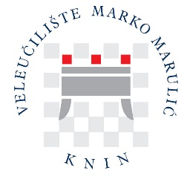

PLANNING YOUR TRAVEL

Flying to Croatia

Information about timetables and destinations is available on the official site of:
- Airport Zagreb:
FRANJO TUĐMAN AIRPORT ZAGREB - https://www.zagreb-airport.hr/en

- Airport Split:
SAINT JEROME AIRPORT KAŠTELA - https://www.split-airport.hr/index.php?lang=en

- Airport Zadar:
Zadar Airport ZEMUNIK DONJI - https://www.zadar-airport.hr/en

Railway travel

Croatia has direct railway links with many European countries and cities. Information about Croatian railways and connections to Knin can be obtained at https://www.hzpp.hr/en.

Bus travel
Bus lines connect all parts of the country. Regular international bus lines connect Croatia with all neighbouring countries. For information about national and international bus lines, please check the Central Bus Station site in Zagreb at https://www.akz.hr/en.
The easiest way to reach Knin from abroad is to fly to Split, Zadar or Zagreb and take a train or bus to Knin.

Approximate road distance between Knin and some European cities:

City | Road distance (km)
Athens | 1277
Barcelona | 1751
Bucharest | 1282
Budapest | 640
Bratislava | 720
Lisbon | 2909
Madrid | 2355
Milan | 785
Munich | 766
Paris | 1609
Plovdiv | 1233
Prague | 977
Trieste | 375
Vienna | 654
Zurich | 1058

Note: Your buddy appointed to assist you during your stay in Knin will be waiting for you at the railway or bus station in Knin and will help you to accommodate after arrival. Therefore, you should plan your arrival during the daytime.

