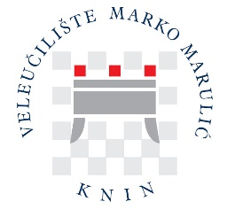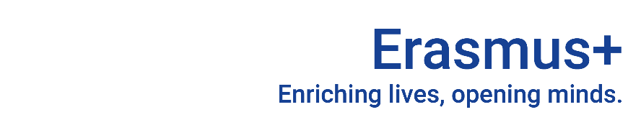

NOMINATION AND APPLICATION PROCEDURE

Dear ERASMUS/Exchange Student,
Congratulations on being selected as an exchange student for the University of Applied Sciences Marko Marulic of Knin (UASMMK)!
We want to provide additional information about the academic calendar, courses, application procedure, admission, visa, residence permit, health insurance and accommodation.

ACADEMIC CALENDAR
The academic year at the UASMMK is divided into two semesters. The first winter semester starts in the first week of October and ends in January. The first examination period takes place in February. The second summer semester starts in the first week of March and lasts until the middle of June. The second examination period starts in the second part of June and lasts until the end of July. August is the time of summer vacation, and September refers to the third examination period.

COURSES SELECTION
Courses can be selected only from the list of courses of the UASMMK your University has the Erasmus bilateral agreement with. Please consult the website (www.veleknin.hr) or the Erasmus coordinator (erasmus@veleknin.hr, smandini@veleknin.hr) at UASMMK.

APPLICATION PROCEDURE
Before Starting the application procedure, ensure Your University sends an official NOMINATION (e-mail form) to the following address: erasmus@veleknin.hr.
Once your home University has nominated you to participate in Erasmus+ mobility, you should complete the APPLICATION for admission at the University of Applied Sciences Marko Marulic of Knin (UASMMK), which consists of the following OBLIGATORY DOCUMENTS:
- Erasmus Application Form (filled in electronically and signed by student and sending institution coordinators):
https://www.veleknin.hr/wp-content/uploads/2024/02/7.a.-Application-form.doc

- Learning Agreement proposal (signed by student and sending institution coordinators):
https://www.veleknin.hr/wp-content/uploads/2024/02/7.b.-Learning-agreement-for-studies.doc
https://www.veleknin.hr/wp-content/uploads/2024/02/7.c.-Learning-agreement-for-traineeships.doc
- Transcript of Records (in English language, signed by authorized persons):
https://www.veleknin.hr/wp-content/uploads/2024/02/7.d.-Transcript-of-records.docx
- Copy of the ID card or passport page with personal data
- 1 passport-size personal photo
Completed application forms and accompanying documents are to be sent in scanned versions in .pdf to the e-mail smandini@veleknin.hr.

Deadlines for application:
For winter semester: 10 June
For summer semester: 10 November
Training applications are accepted without specific deadlines, at least one month before the placement starts.

