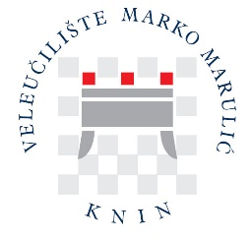

ACADEMIC INFORMATION FOR STUDENTS

Higher education system in the Republic of Croatia

Higher education system in the Republic of Croatia

Following the Bologna system, higher education in the Republic of Croatia has a three-cycle study model, including undergraduate, graduate and postgraduate study. Like several other European higher education systems, the Croatian system has a binary structure comprising the professional and University profiles of study programmes and institutions.

Professional studies are primarily delivered at the undergraduate and graduate levels and focus on the labour market and immediate participation in the workforce. They lead to the acquisition of primarily professional competencies (https://www.azvo.hr/en/higher-education/higher-education-system).

Professional Undergraduate Study programmes – The first cycle takes three years, in which students must earn 180 ECTS credits. Upon completion, students are awarded a diploma and the academic degree of Bachelor indicating the field of study.

Professional graduate programmes – the second cycle takes two years, in which students must earn 120 ECTS credits. The total number of credits earned in the first and second-cycle programmes must be at least 300. Upon completion, students are awarded a diploma and the academic degree of Master, indicating the field of study.

Students holding second-cycle university degrees can continue their studies in postgraduate programmes or enter the workforce.

Additional information about the study in Croatia is available in the following scheme:

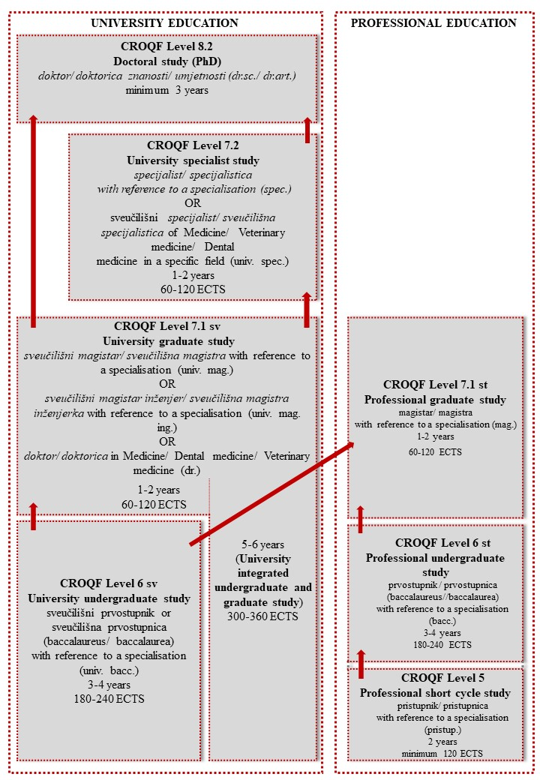

Types of study programmes in the Republic of Croatia
(https://www.azvo.hr/en/higher-education/types-of-study-programmes-in-the-republic-of-croatia)

Professional Undergraduate and Graduate Study Programmes at UASMMK

Professional Undergraduate Study programmes at UASMMK
- Professional Undergraduate Study of Commercial Business with Entrepreneurship
- Professional Undergraduate Study of Karst Agriculture – Plant Production
- Professional Undergraduate Study of Karst Agriculture – Animal Husbandry
- Professional Undergraduate Study of Food Technology

Professional Graduate Study programmes at UASMMK
- Professional Graduate Study of Economics and Normative Frame of Entrepreneurship

Academic year & teaching periods

The academic year at the UASMMK is divided into two semesters. The first, winter semester, starts in the first week of October and ends in January. The first examination period takes place in February. The second, summer semester, starts in the first week of March and lasts until the middle of June. The second examination period starts in the second part of June and lasts until the end of July. August is the time of summer vacation, and September refers to the third examination period.

National Holidays

January 1 | New Year’s Day
January 6 | Epiphany
Easter and the day after | Easter Sunday and Monday
May 1 | Labour Day
60 days after Easter | Corpus Christi
May 30 | Statehood Day
June 22 | Anti-Fascist Resistance Day
August 5 | Victory and Homeland Thanksgiving Day
August 15 | Assumption of Mary
November 1 | All Saint’s Day
November 18 | Remembrance Day
December 25 and 26 | Christmas (University Christmas holidays 25.12.-6.1.)

Courses to be studied at UASMMK

The official language of instruction at UASMMK is Croatian. Courses that are offered in English are listed in the Course catalogue. In coordination with Erasmus coordinators at home, prospective Erasmus students are advised to prepare a preliminary learning agreement before arriving in Knin.
With sufficient knowledge of the Croatian language, Erasmus incoming students are welcome to attend lectures held in Croatian.
For more information about courses, please contact us via e-mail at erasmus@veleknin.hr. We will gladly provide particular information about available courses upon your request.

Explanation of Croatian grading system

National grading system consists of five (5) grades with numerical equivalents, 5 being the highest grade:
- izvrstan (5) – excellent (5)
- vrlo dobar (4) – very good (4)
- dobar (3) – good (3)
- dovoljan (2) – sufficient (2)
- nedovoljan (1) – insufficient (1)

Comparison to ECTS

Achieved success percentage | ECTS |  | Croatian Grade
90 – 100 | A | Excellent | Excellent (5)
80 – 89,90 | B | Above average | Very good (4)
70 – 79,90 | C | Average | Good (3)
60 – 69,90 | D | Below average | Sufficient (2)
50 – 59,90 | E | Fail | Sufficient (2)
0 – 49,90 | F | Fail | Insufficient (1)

City and University Library

The National and University Library in Knin (Narodna knjižnica Knin) is in the same building as the Student Dormitory "Fra Lujo Marun", near the University. The Library is open on weekdays from 8 a.m. to 7.00 p.m. and on Saturdays from 8.30 a.m. to 12.30 p.m. Before using library facilities, services and computer rooms, students must register and obtain a member card. The UASMMK students are exempt from paying membership fees.

