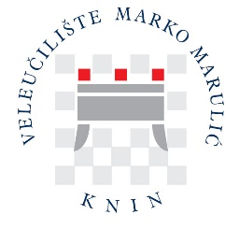

OTHER USEFUL INFORMATION

Important telephone numbers

Emergency alert: 112
Police: 192
Fire brigade: 193
Ambulance: 194
Road assistance (HAK): 9987
Bus station (Knin): +385 (22) 661 005
Hospital (Knin): +385 (22) 201 600

Money

As of 01 January 2023, Croatia's official currency is the euro (EUR).
Cash can be withdrawn from ATMs with internationally valid debit cards.

Credit cards

Most restaurants and shops accept all major credit cards (American Express, Mastercard, Visa).

Pharmacies

Pharmacies in Knin are open all day, usually from 7 a.m. until 7 p.m. One pharmacy is located in the same street as the University and the Student Dormitory "Fra Lujo Marun", only 50 meters away.

Postal and Telephone Services

The post office in Knin is open Monday to Friday, from 7 a.m. to 6 p.m., and Saturdays from 8 a.m. to 12 p.m. Post stamps can be bought at post offices or kiosks.
The international telephone access code for Croatia is +385. The area code for Knin is 022. Omit 0 (zero) in 022 when dialling from abroad. You can call from the post office or public telephone booths for international calls. Croatia is currently hosting many GSM networks, of which T-Mobile Croatia (network code 098), A1 (network code 091), TOMATO (network code 092), TELEMACH (network code 095) and BONBON (network code 097) are the most used. All these operators provide pre-paid mobile services.

Shops

Shops and local groceries are open Monday to Saturday, usually from 8 a.m. to 8 p.m., and Sundays until 1 p.m.

Nature, culture, and heritage of Knin and its surroundings

Knin Tourist Board - https://www.tz-knin.hr/en/home/

